BEM 103Introduction to Finance. Practice MID-TERM EXAMINATION 2026 PAGE 1

Instructions: This exam should take about 40 minutes, but you have the whole hour.
1. Net Present value
Robinson Crusoe is contemplating planting corn and breadfruit to increase his food supply, which will run out in one year. Corn requires 1 hour of work per pound produced, and it must be planted every year. A plantain tree requires 15 hours of work a year to first harvest and continues to produce 10 pounds of fruit each year indefinitely. Crusoe expects to be on the island for two years and he is equally happy to eat corn or plantains as long as he has 400 pounds of food to each year.
  - (2pts) what is the present value equation of subsisting on corn?
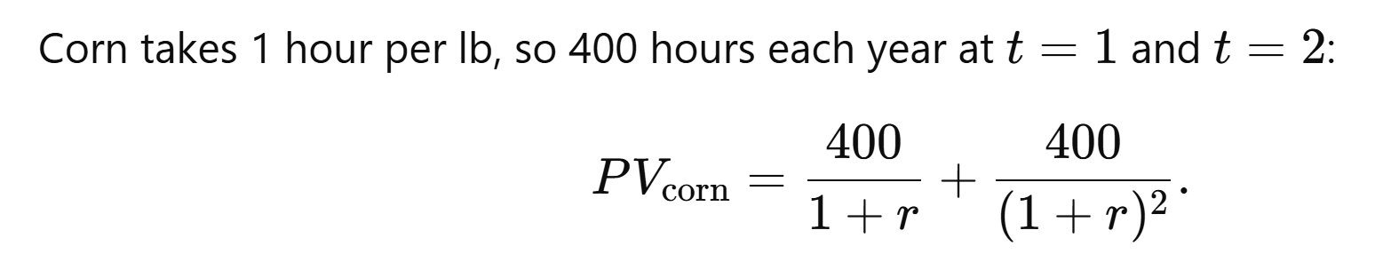
  - (2pts) What is the present value equation for subsisting on plantains?
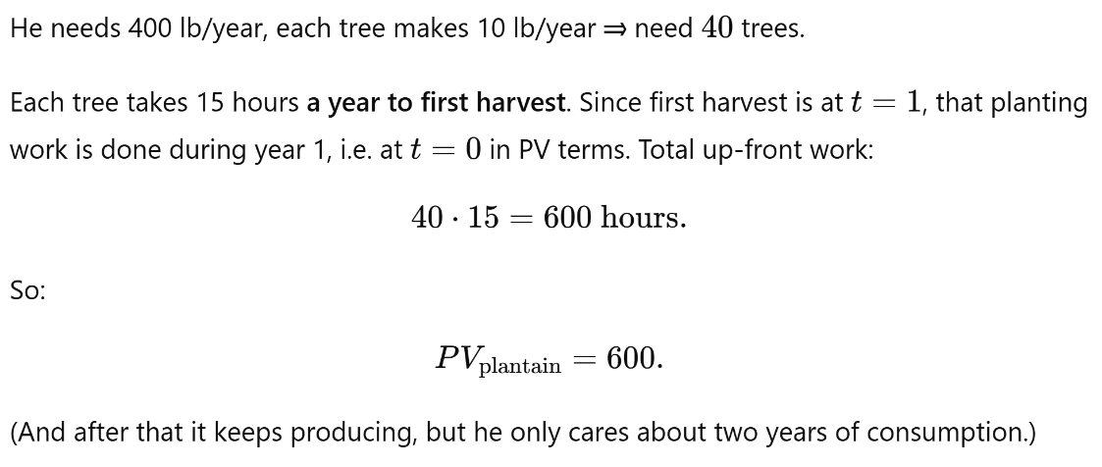
PV equation (although superfluous) would be as follows:
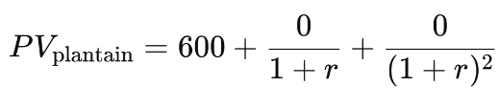
  - (3pts) What is the discount rate that makes Crusoe indifferent between corn and plantain?
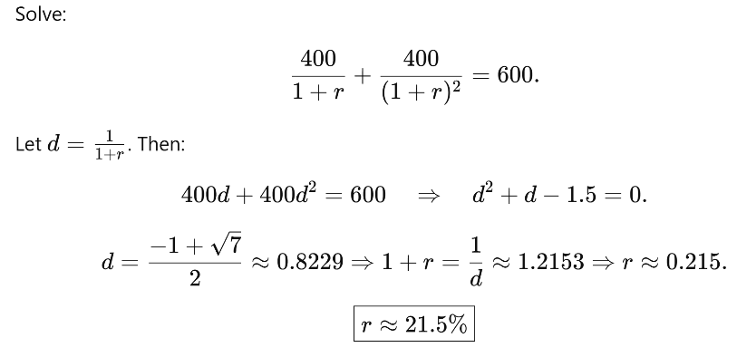
  - (1.5pts) Suppose that there is a 50% chance that Crusoe is rescued each year. How does that change the calculations?

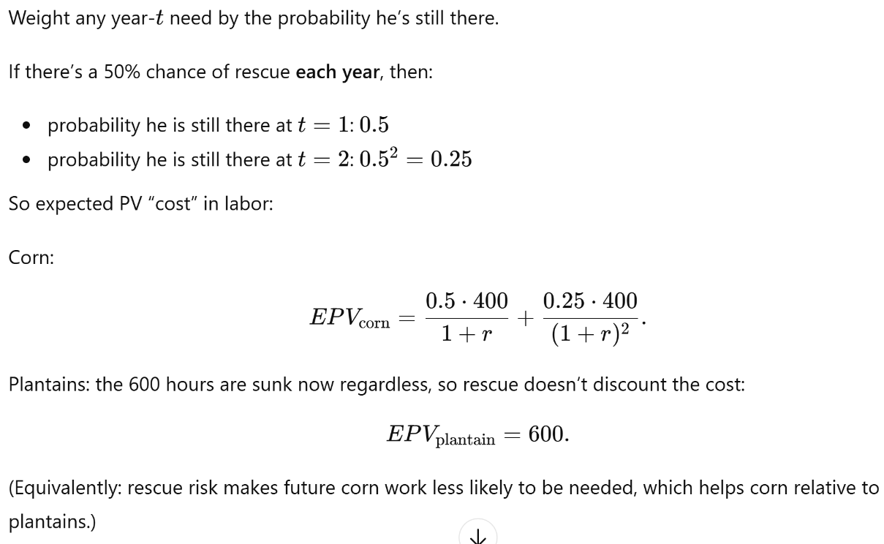

1.5 (1.5pts) If his discount rate is 0.8, what will he choose to do? Will he regret that if not rescued in year 1?
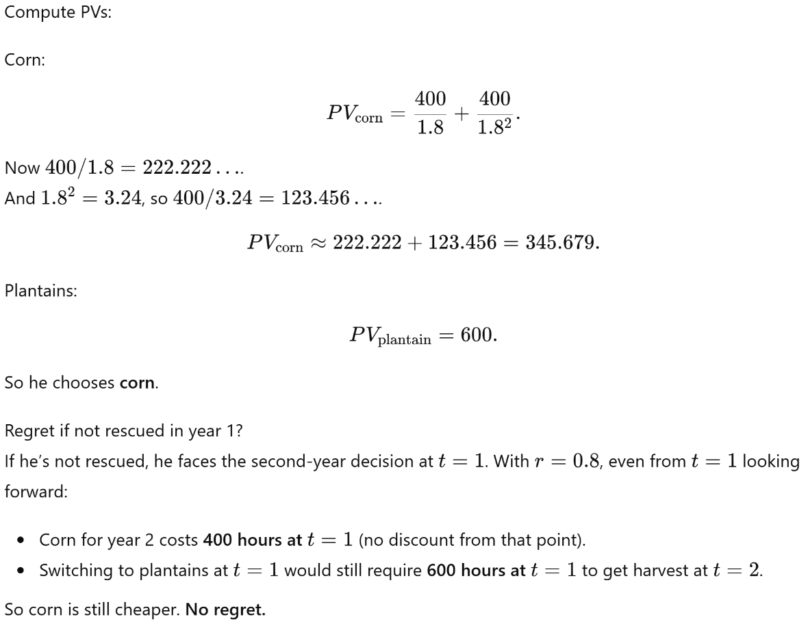

2 Banks and Risk
The Bank of Pasadena (BoP) borrows from depositors at 4% it makes one-year business loans. 10% of the loans will go into default, and the bank will recover half the money it lent, with no interest. For each question, set up the problem and then solve it.
2.1 (2pts) What is the interest rate it should charge to break even on the loans?
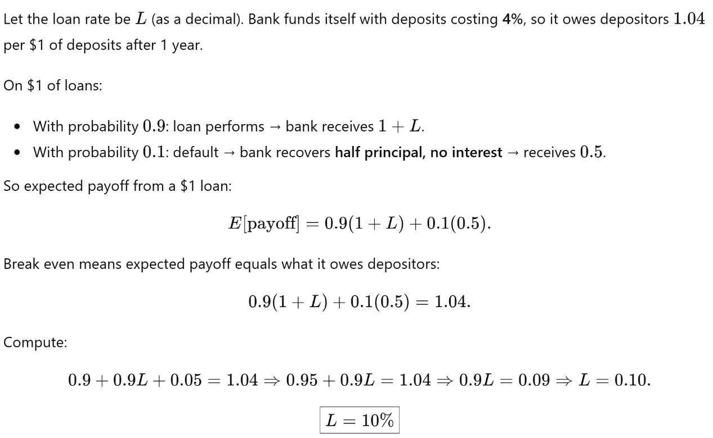

2.2 (3pts) The bank makes 100 loans of $100,000. It faces a ‘stress’ test that requires it to have enough equity to pay off its lenders even if 30% of its loans go into default (3 times the expected rate). What are the losses on the loans in this case and how much equity should BoP have?
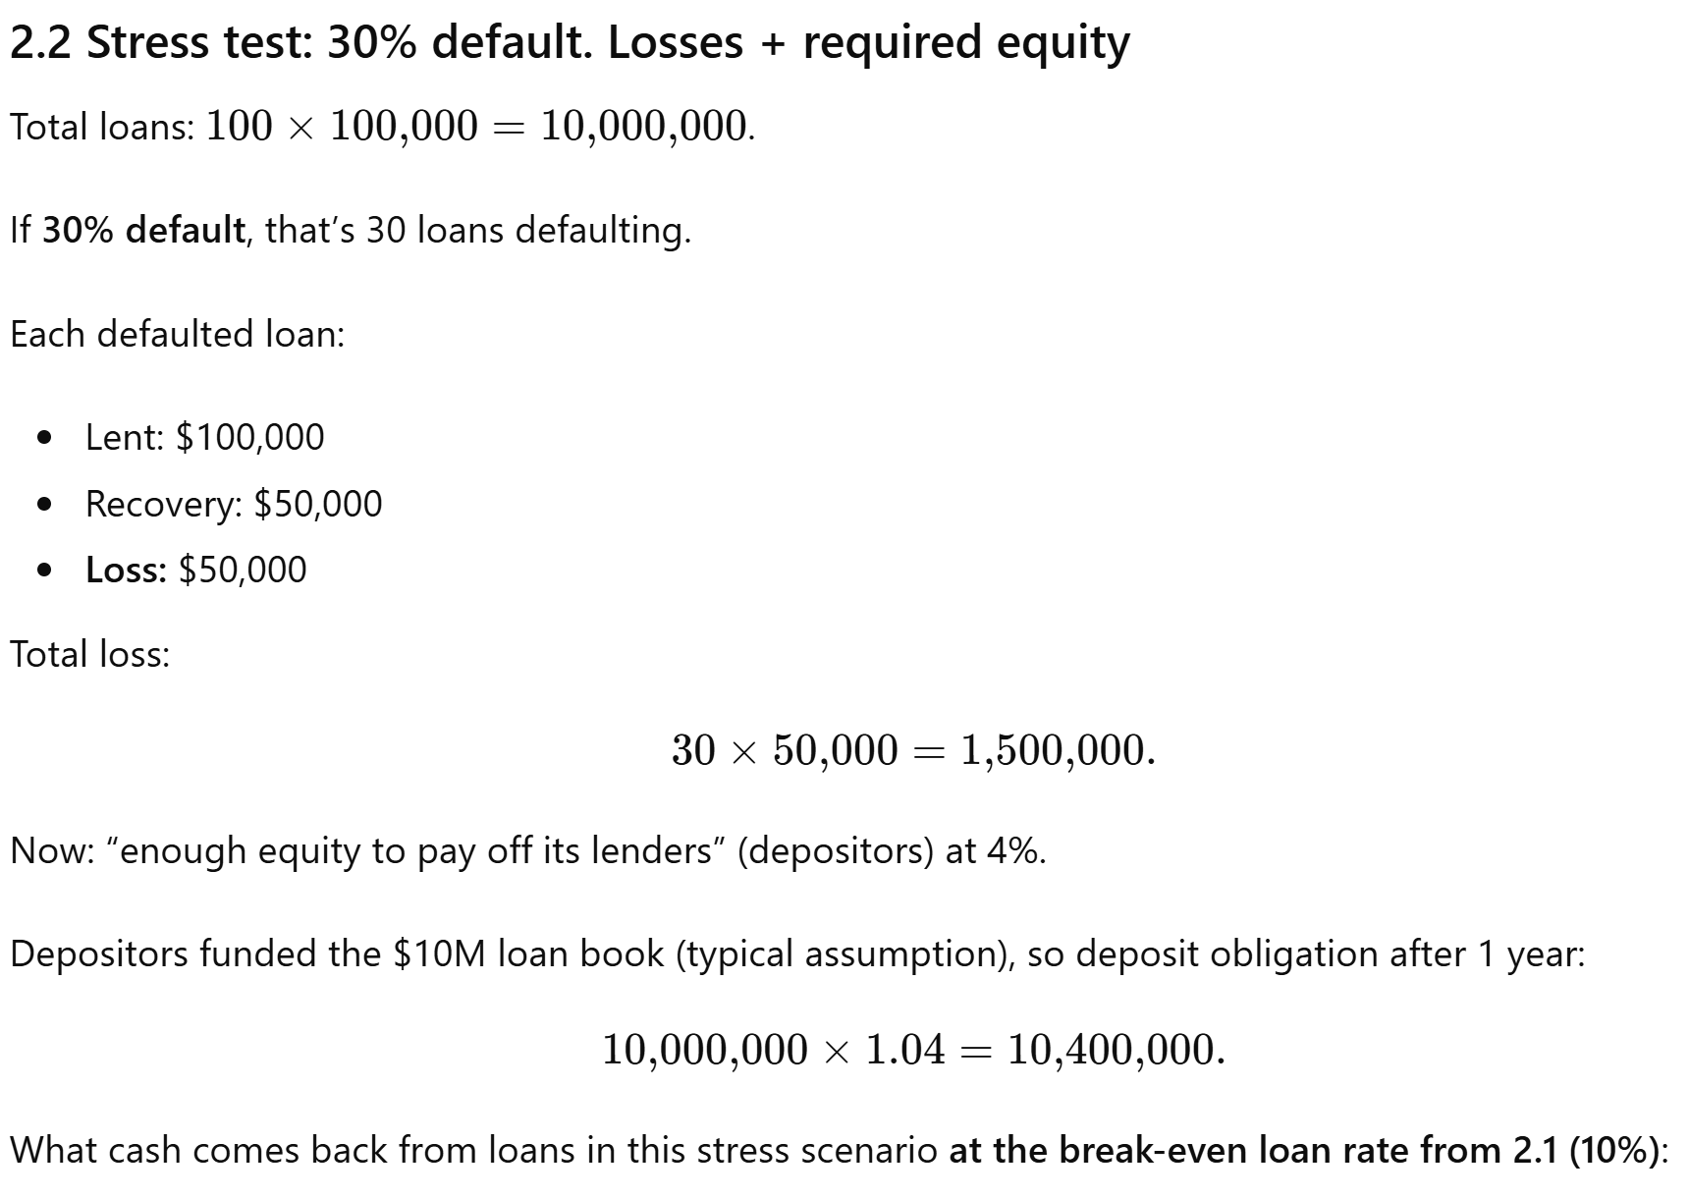
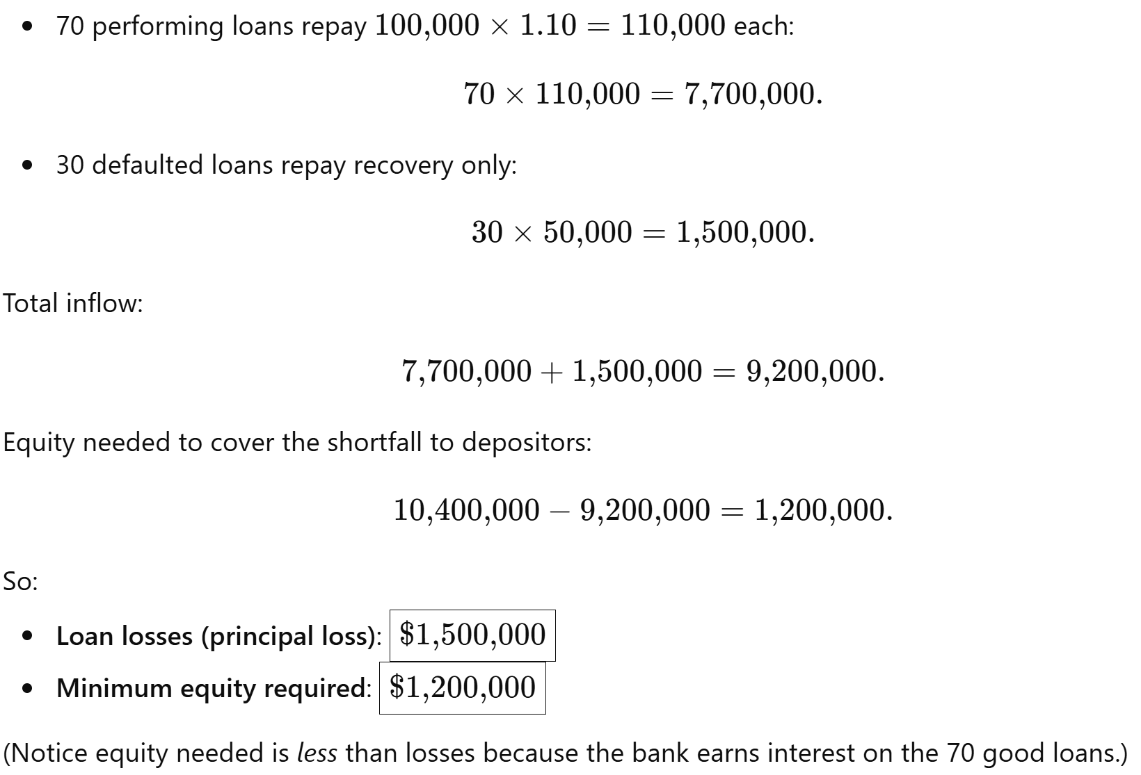

2.3 (2pts) The bank makes 100 loans of $100,000. It faces a ‘stress’ test that requires it to have enough equity to pay off its lenders even in the case of a mid-year jump in interest rates to 6% (the default rate is 10%). What are the losses on the loans in this case and how much equity should BoP have?
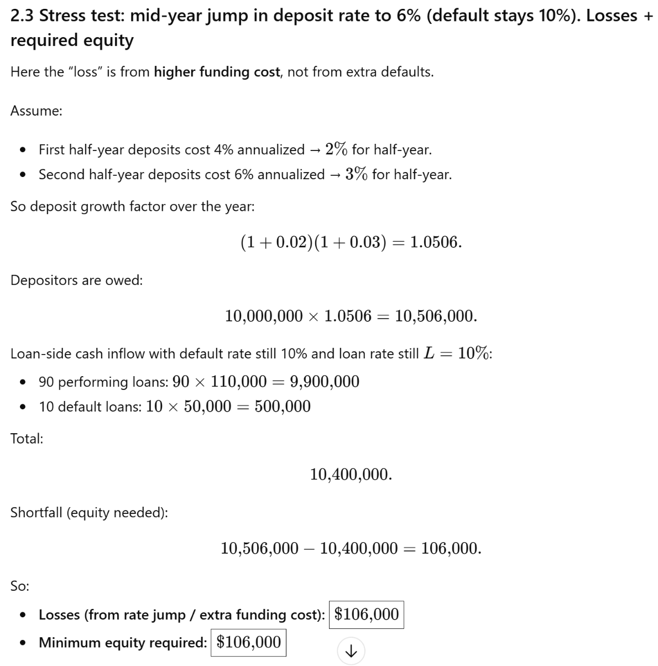

2.4 (3pts) If the probability of an interest rate jump is 50% and a recession (default rate jump) is 50% but the two never occur together, how would you revise the interest rate the bank has to charge to break even on its loans?
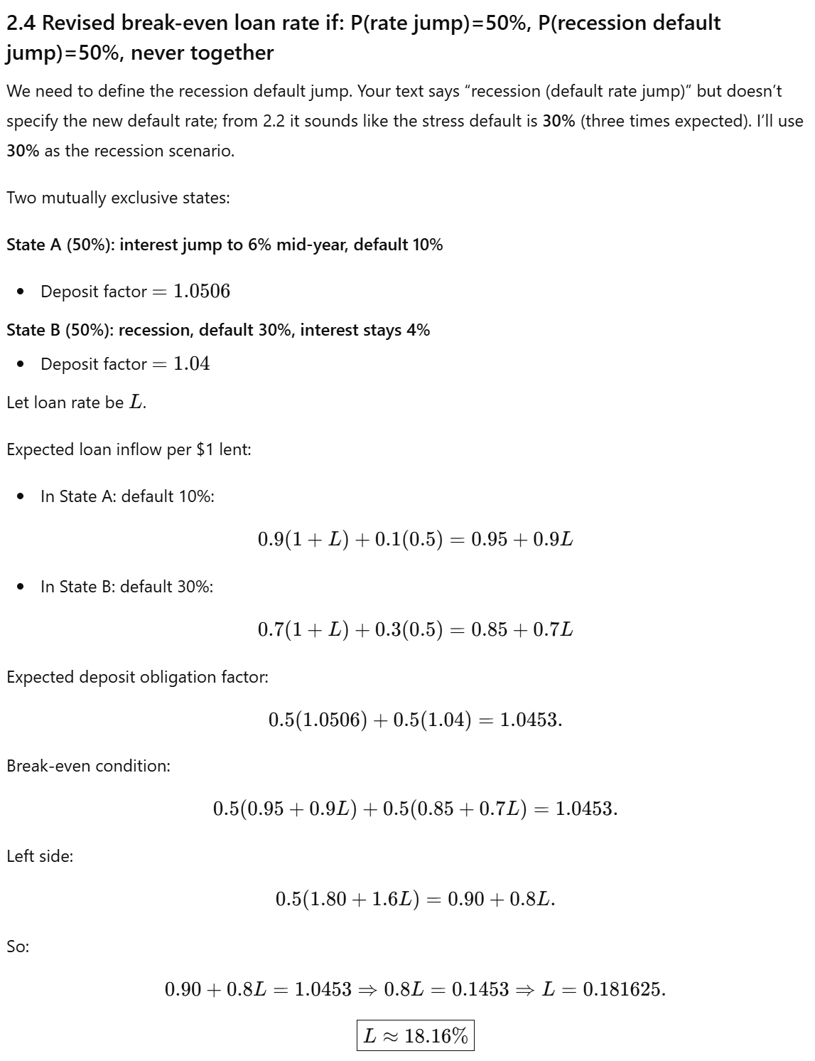
3 Term Structure of interest rate
SGB is a bank who must hold as reserves capital equal to at least 10% of its total loan reserves. It has a billion dollar in loans. It can choose between holding these reserves either in one or two year no coupon bonds.
3.1 (1pt) If the interest rate is 10% what is a good approximation of the discount rate?
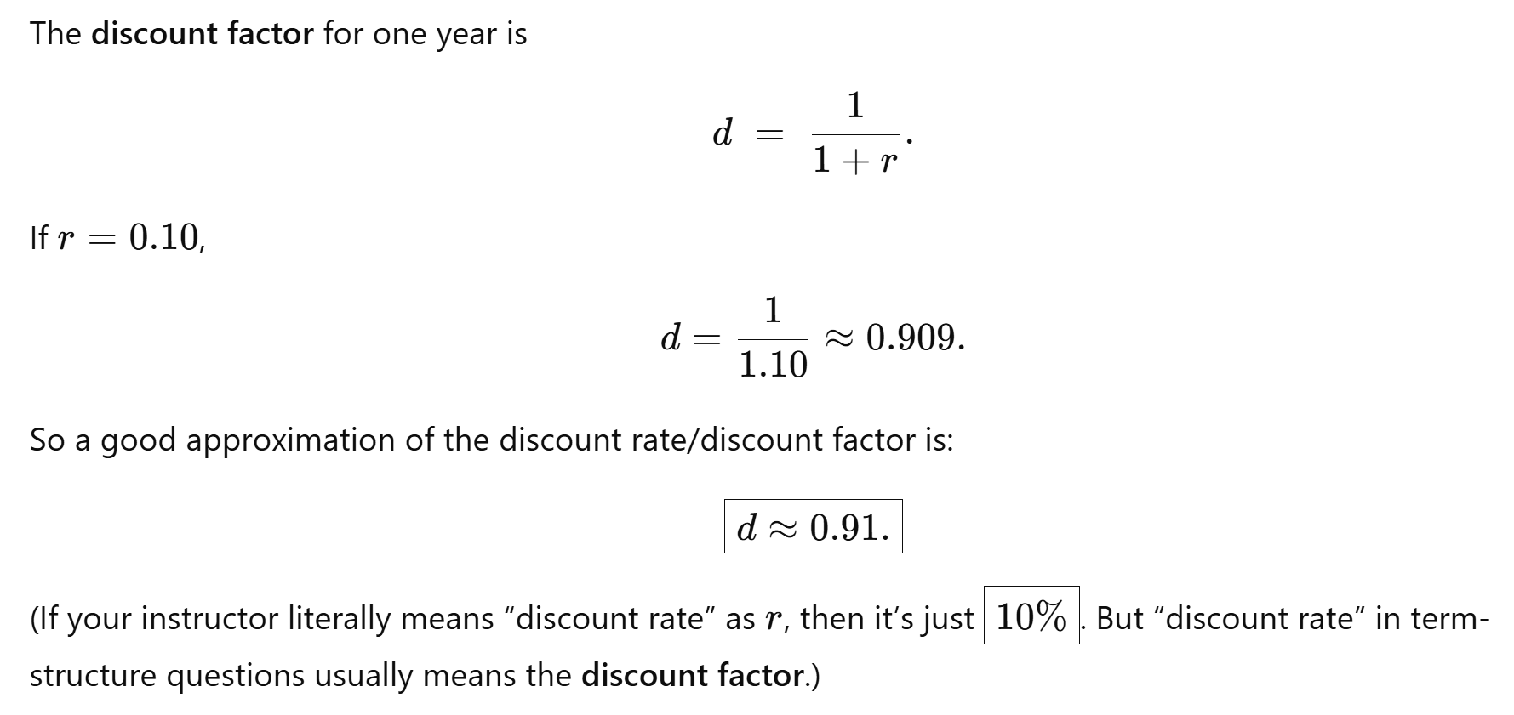
3.2 (2pts) what is the price of the one year and of the two year zero coupon bonds.
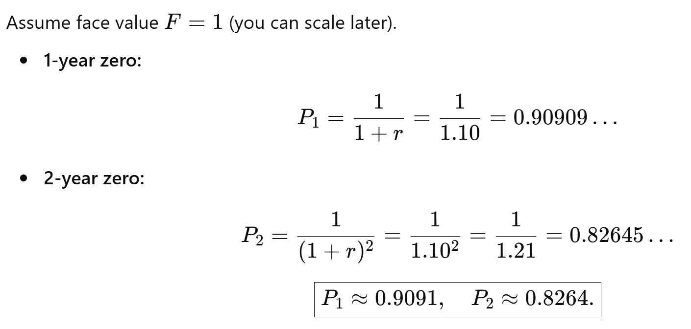
3.3 (1pt) in this case does the bank care how it holds its reserves.
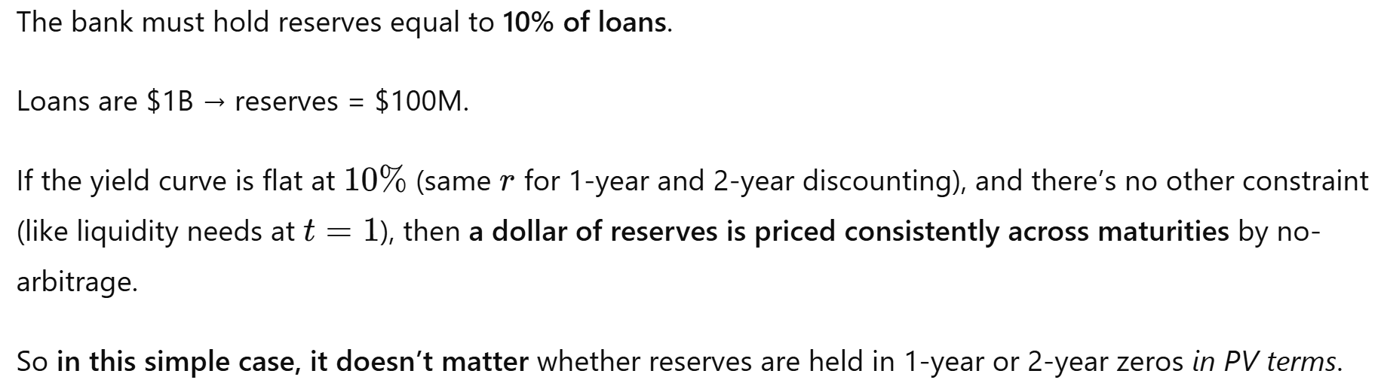

3.4 (2pts) right after the bank makes its investment decision. An unexpected and unanticipated interest rate shock of +2% hits the market it persists for two years. Write a formula for the price of each bond after the shock has occurred. Which has a greater price fall? Are the yields different? (you can compute the yields but you do not have to).
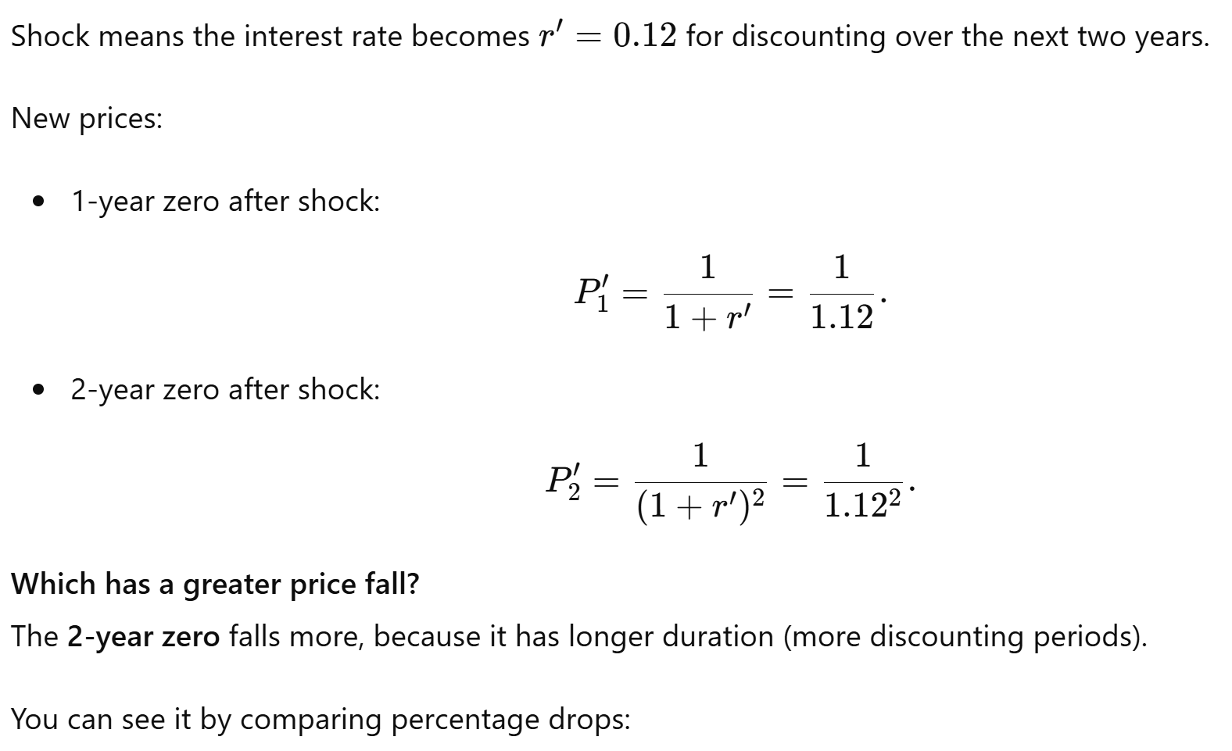
- 1-yr bond’s price drop ~ 1.79% vs. 2-yr bond’s price drop of ~3.55%
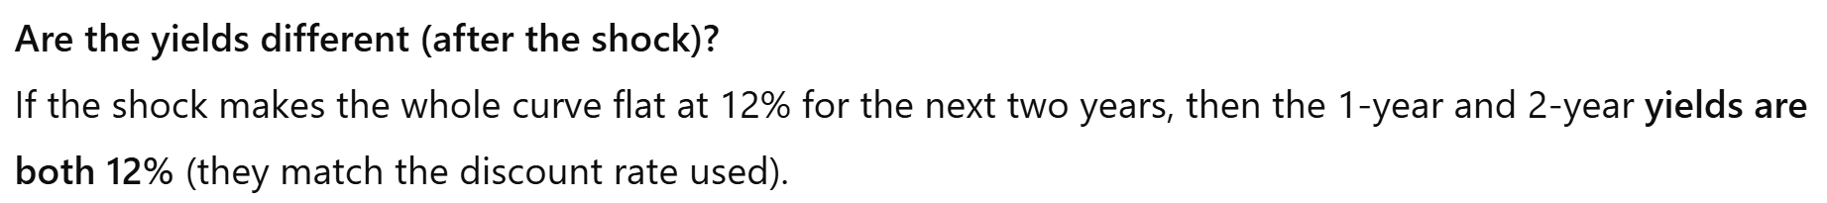

3.5 (3pts) Now on the day the bank makes its investment decision, everyone knows the probability of the shock occurring in any year is 0.5 and independent. Which of the two bonds has a higher yield?
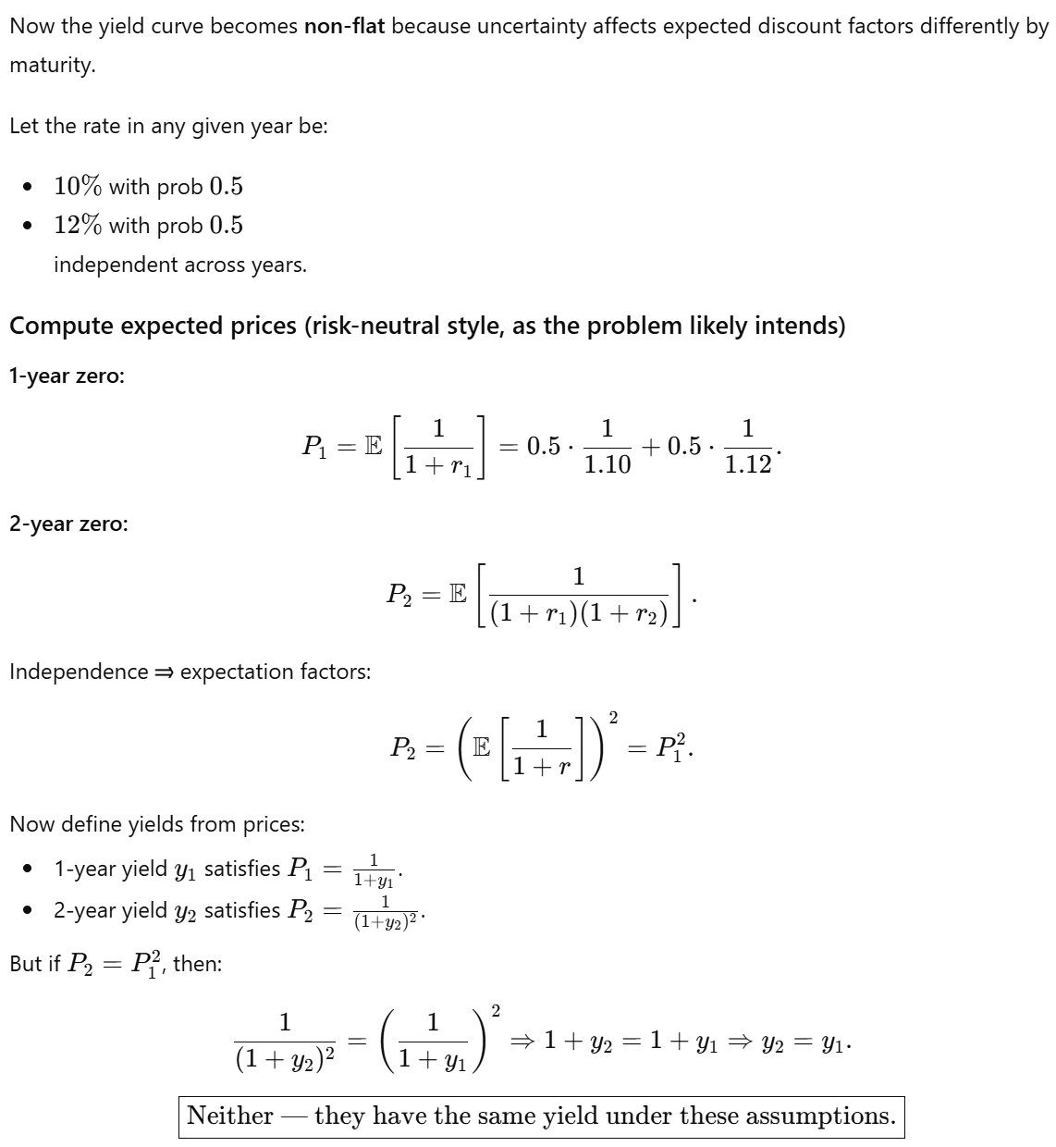
4. Efficient Frontier
Two stocks
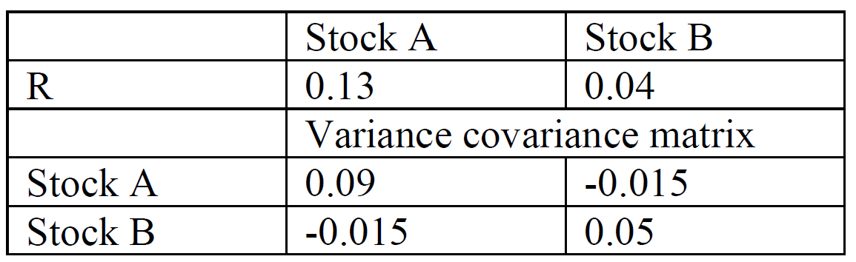
For each question below, a portfolio must report the proportion invested in each asset, its expected return and variance. Your decisions are being made with no short sales and no riskless asset.
4.1 (1 pt) what is the weight on Stock A required for each value of the desired return 0.04 to 0.13 returns in 0.01 increments.
See Ch-7 class notes pages 16-23, Portfolio frontier with 2 assets (with and without short sales). Make sure you understand. If not, ask the TA. I dunno how the teacher expects you to do these questions without a computer! See the formulas on page 17 where your teacher uses r_{P} for return (r_{P} = wr₁+(1-w)r₂) whereas ChatGPT is using μ_{P} in this question… so don’t get confused with simple terminology.
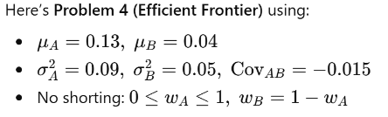

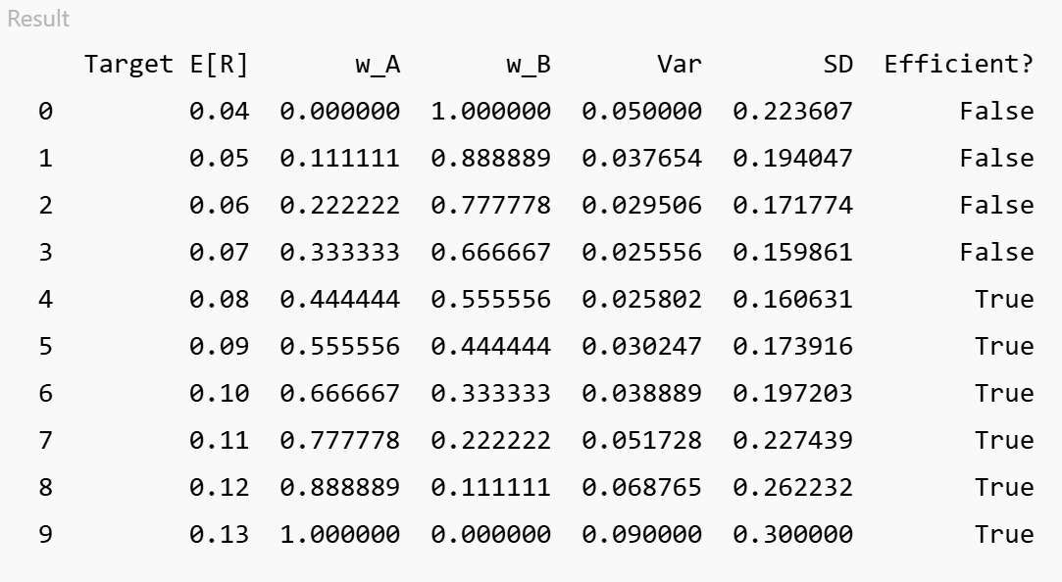 | 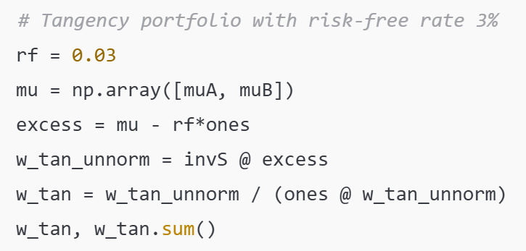
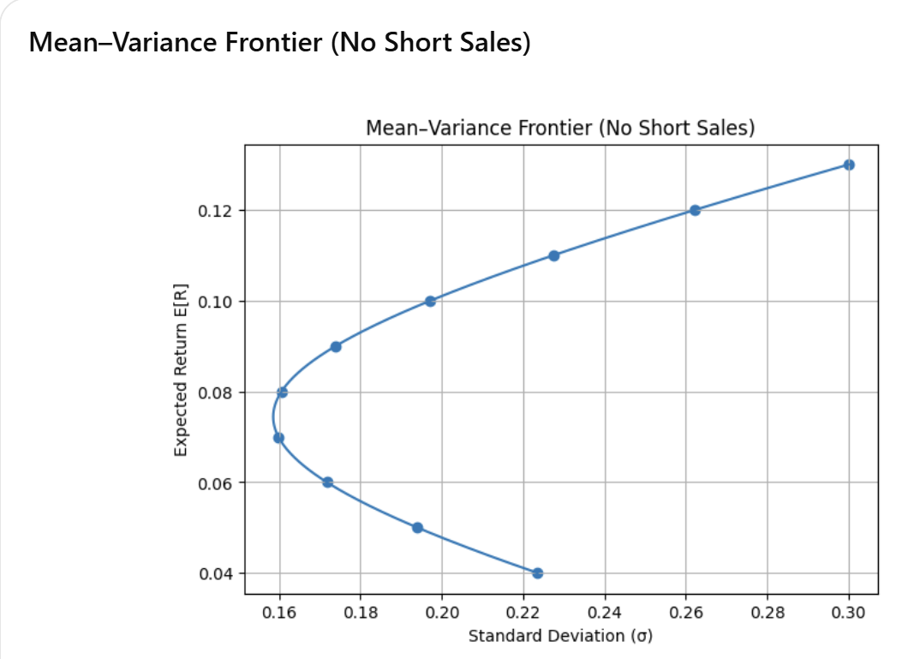 | 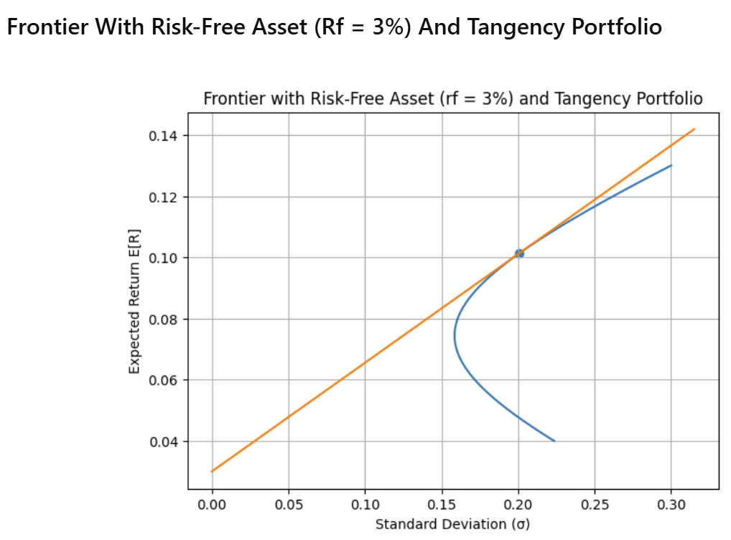

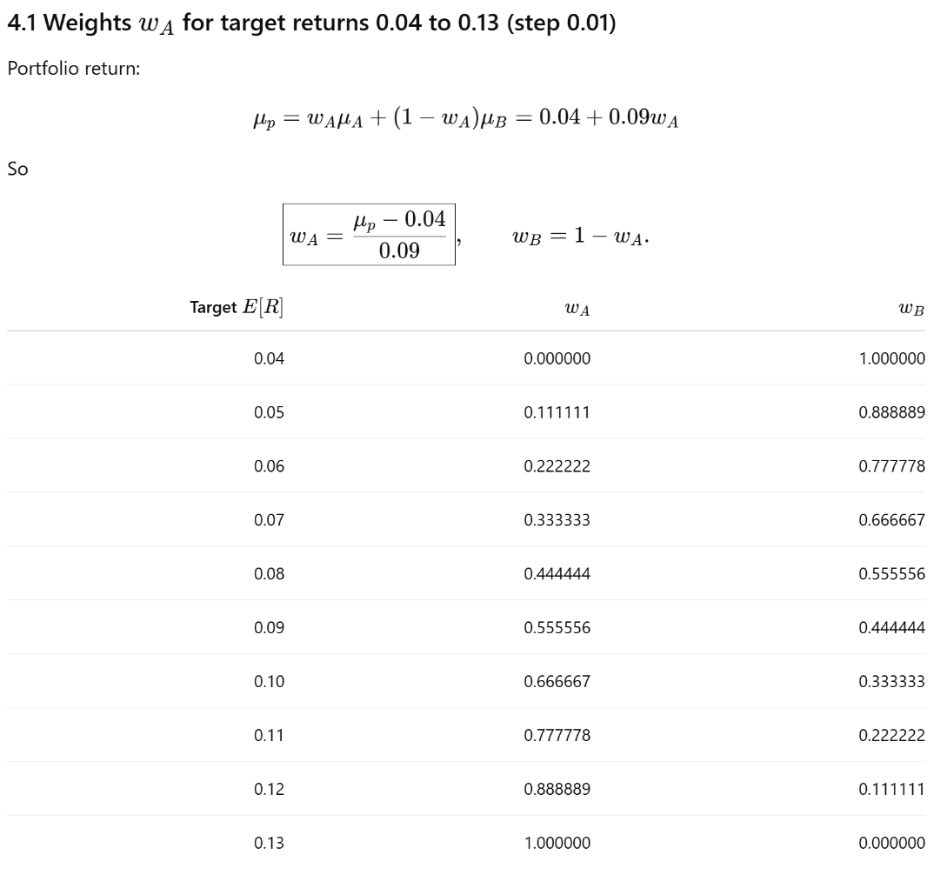
4.2 (3 pts) what are the variances of each of these portfolios?
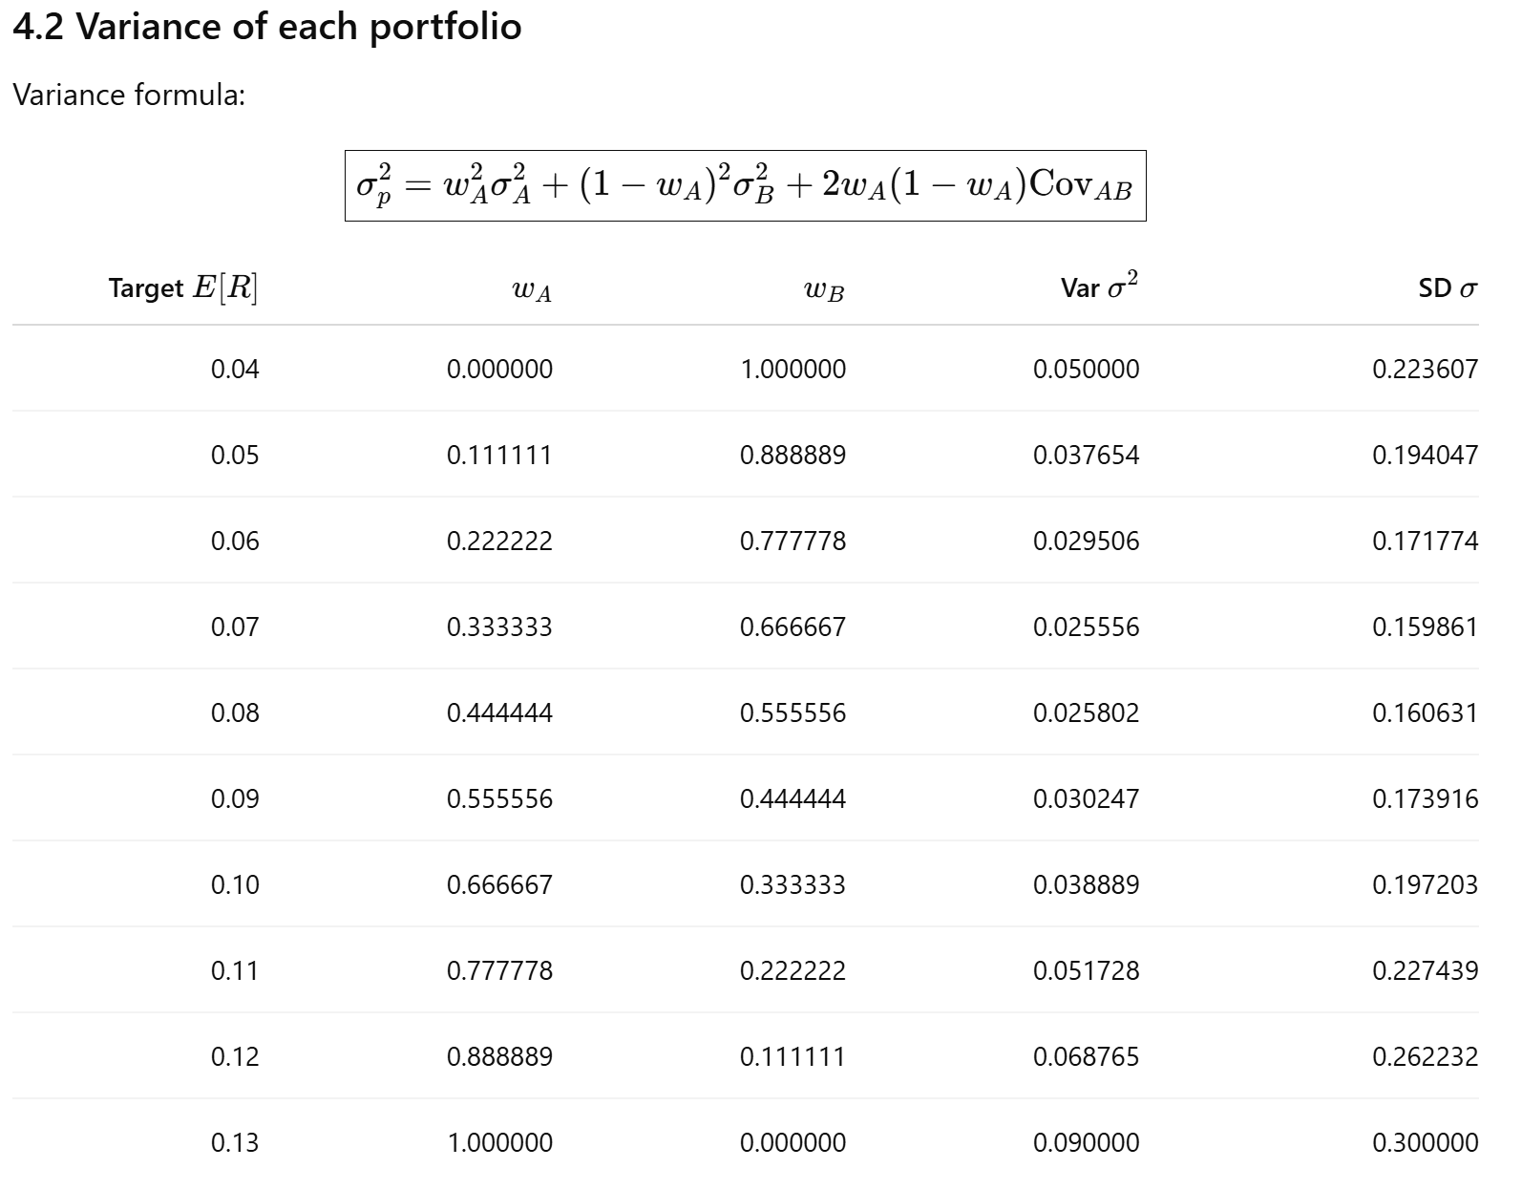
4.3 (1 pts) graph the resulting mean-variance frontier
Curve “bows left” as covariance is negative

4.4 (2 pts) Which of these portfolios are dominated?
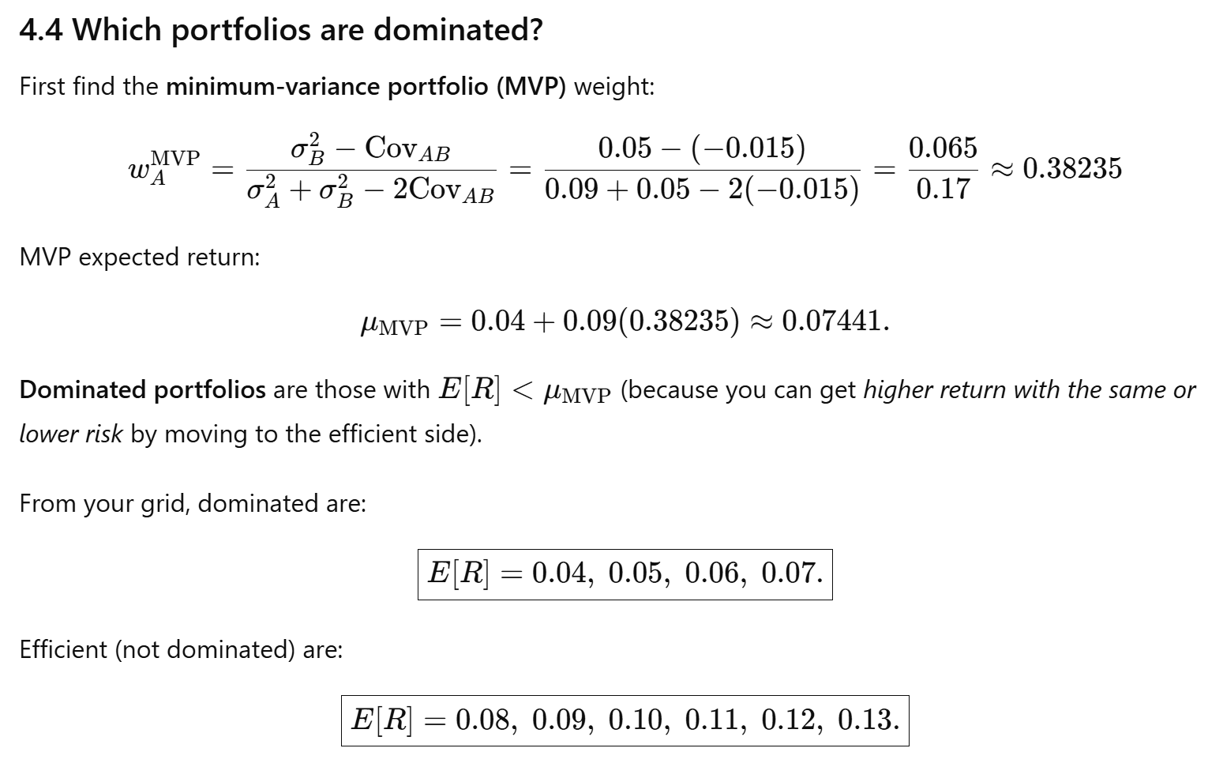

4.5 (3 pts) now assume a riskless asset is available with a return of 3%. Graph the new mean-variance frontier, and the Sharpe optimal portfolio
